





Account Registration Instructions

For Responsible Officials

Iowa Department of Natural Resources
Wallace State Office Building
Air Quality Bureau
502 E 9th St
Des Moines, IA 50319

Contact the Iowa EASY Air Helpdesk
email: easyair@dnr.iowa.gov
Or call (515) 725-9569 or (515) 204-3749

Table of Contents

1. Iowa EASY Air Website Login 3
2. Self-Registration 4
2.1 Fill in General Information 4
2.2 Indicate Account Type 5
2.3 Associate Facility or Facilities 6
2.4 Select and answer Security Questions 9
2.5 Pass Picture Verification 10
2.6 Select Identify Proofing Option 10
2.6.1 e-Verify Option 11
2.6.2 Electronic Signature Agreement (ESA) Option 13
2.7 Receive email confirmation from Iowa EASY Air 13
3. Access Your Account Information 14
4. Request a New Facility Number or Process a Facility Change 15

List of Figures

Figure 1 - Iowa EASY Air Website Login Page 3
Figure 2 - Access Self – Registration 4
Figure 3 - Fill in General Information 4
Figure 4 - Select Account and Submittal Groups 5
Figure 5 - Associate Facility 6
Figure 6 - Associate Facility Search 6
Figure 7 - Associate Facility Search - No Facilities Found 7
Figure 8 - Select Facility from Facility List 7
Figure 9 - Selection Confirmation Screen 8
Figure 10 - Select Facility from Facility List 8
Figure 11 - Security Questions 9
Figure 12 - Picture Verification 10
Figure 13 - User Verification Options 10
Figure 14 - e-Verify Option - Enter User Information 11
Figure 15 - e-Verify Successful 11
Figure 16 - e-Verify Completed 12
Figure 17 - e-Verify Unsuccessful 12
Figure 18 - Electronic Signature Agreement (ESA) Option 13
Figure 19 - Account Confirmation Email 13
Figure 20 - Access “My Account” 14
Figure 21 - Successful e-Verify Results 14

To access Iowa DNR’s Environmental Application System for Air (Iowa EASY Air), users must first register and then log into the system to complete their account. This document explains how to register as a Responsible Official (RO) in Iowa EASY Air, sign into the system, and access your account information.

Iowa EASY Air Website Login
Use a reliable Internet connection and a current web browser (e.g. Edge, Chrome, Firefox, Safari, Opera IE 11, etc.) to access the login page of the Iowa EASY Air website. When the screen shown in Figure 1 appears, you will need to determine if you need a new account or if you already have an account.
Obtaining a User Name and password requires self-registering for the system. Make note of the bottom check marked section (circled in red) before creating a new account, as you may already have a migrated account.
This document covers the steps to take for a new user to set up a new account.
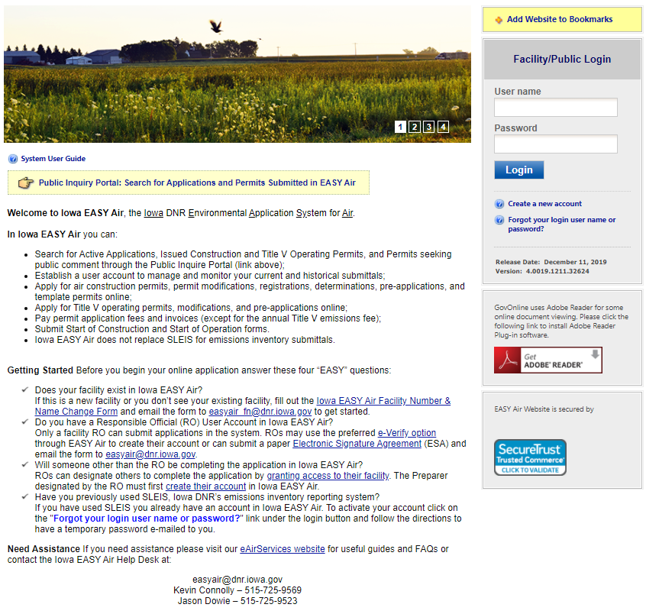
Figure 1 - Iowa EASY Air Website Login Page

Self-Registration
Click on “Create a new account” (Figure 2). Follow instructions 2.1 – 2.7 to register.
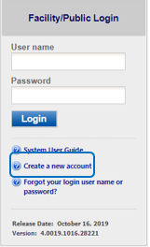
Figure 2 - Access Self – Registration

Fill in General Information
The registrant needs to complete all required fields in Figure 3 (denoted with a red asterisk). if you wish to receive text messages from the system, enter a mobile phone number and select your cellular provider (If your provider is not listed, please notify the Help Desk). When finished, click the blue “Next>>” button
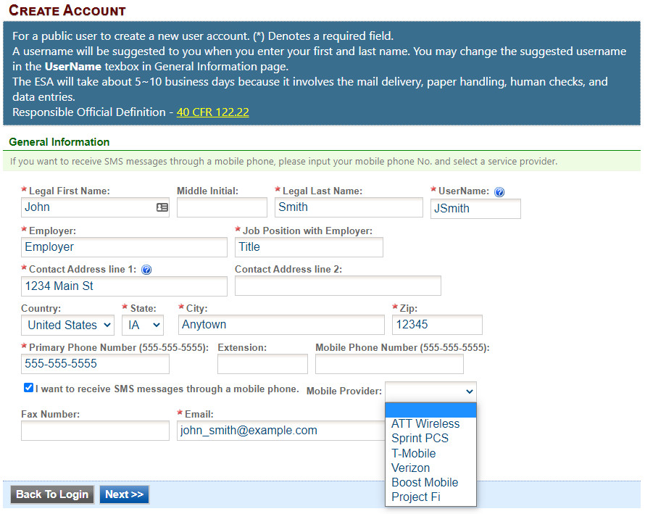
Figure 3 - Fill in General Information

Indicate Account Type
There are two user account types having different roles. An explanation of each of these roles is provided below (Table 1). The RO user role has additional privileges above the level of the Preparer.
Table 1 - Account Types in Iowa EASY Air
User Type | Account Privileges
Responsible Official (RO) | - Will be issued a PIN once their account privileges are approved by IOWA DNR  - Certify and submit an electronic data entry form in Iowa EASY Air  - Manage Preparers and Consultants  - View and prepare an electronic data entry form in Iowa EASY Air  - View submitted data in Iowa EASY Air  - Keep track of the status of submitted records
Preparer | - View and prepare an electronic data entry form in Iowa EASY Air  - View submitted data in Iowa EASY Air  - Keep track of the status of submitted records

If you are uncertain as to which role applies to you, contact the EASY Air Helpdesk at (515) 725-9569 or (515) 204-3749; or send your inquiry to easyair@dnr.iowa.gov.

Choose the “Responsible Official” user role (Figure 4). Select one or both of the Submittal Group(s) for the user (circled checkbox). This determines the types of applications the RO may submit to the Air Quality Bureau. Select either RO for Construction or RO for Title V or RO for both. When you make a choice in either Submittal Group, the Associated Facility List will open.
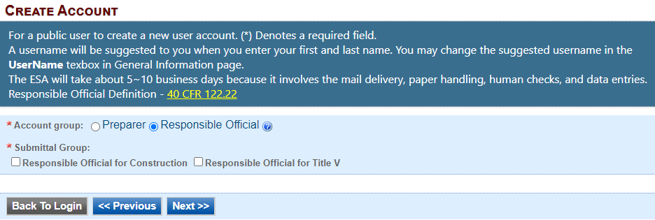
Figure 4 - Select Account and Submittal Groups

Associate Facility or Facilities
As a RO (Responsible Official), the user may now associate a facility or facilities to his/her account (Figure 5).
If your facility is not found after searching, complete and submit the Facility Number & Name Change Form (DNR Form 542-1056) using the highlighted link in Figure 5.

Click on the yellow “Associate Facility” button to launch a search window (Figure 6).
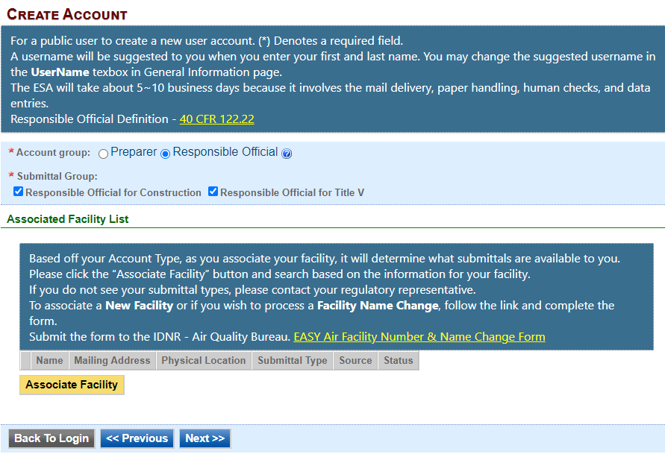
Figure 5 - Associate Facility
Figure 6 (below) displays on top of Figure 5. When associating a facility, the user can search the facility based on Facility Name, Address or Facility Number. Choose one field to search and click the blue “Search” button.
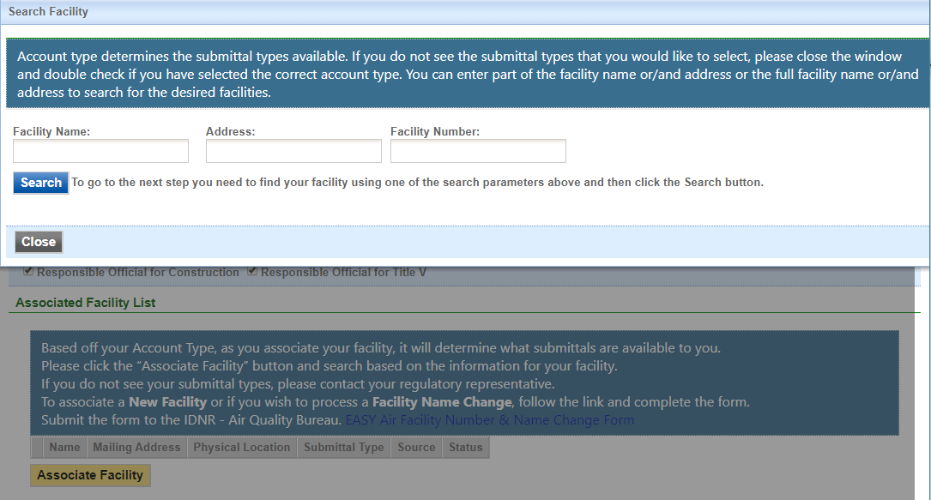
Figure 6 - Associate Facility Search
If your search returns no facilities, Figure 7 indicates the result and informs the user to contact the Iowa DNR Air Quality Bureau.
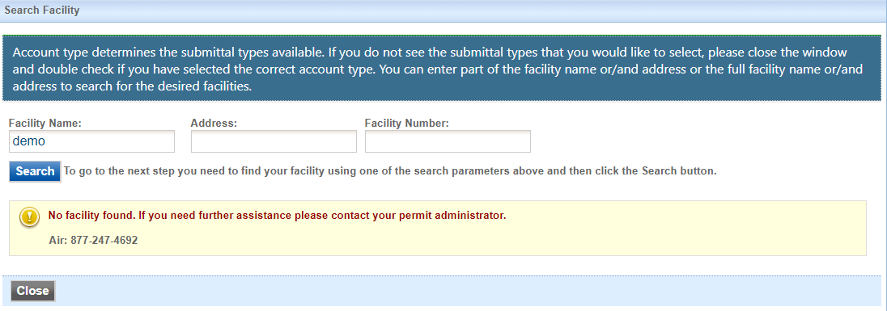
Figure 7 - Associate Facility Search - No Facilities Found

A search for EASY AIR will retrieve facility list from Iowa DNR’s State Facility Database (Figure 8).
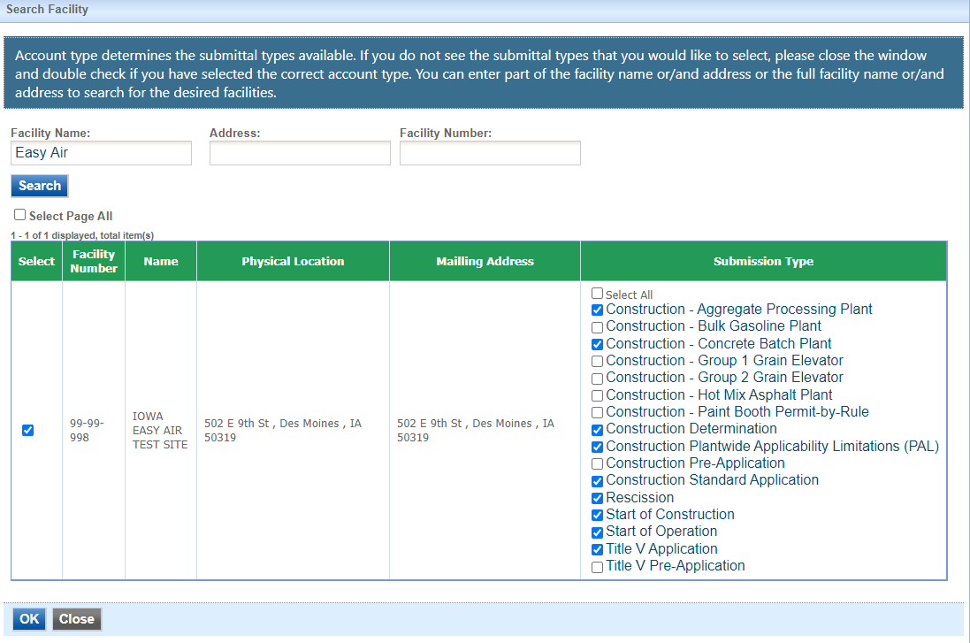
Select Your Facility
Select One or More Submission Types
Figure 8 - Select Facility from Facility List

Use the checkboxes to identify the facilities and types of applications (submissions) the RO will submit.
When all facilities and submission types have been selected, click the blue “OK” button.
A confirmation window will appear at the top of the screen (Figure 9), click the blue “OK” button.
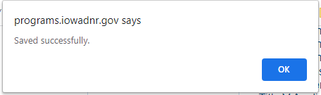
Figure 9 – Facility Selection Confirmation Screen

Figure 8 will appear again, scroll to the bottom of the screen and click the gray “Close” button.

After clicking the gray "Close" button, the user will be returned to the screen from Figure 5, but will now show the facilities and permit submission types that were selected (Figure 10).
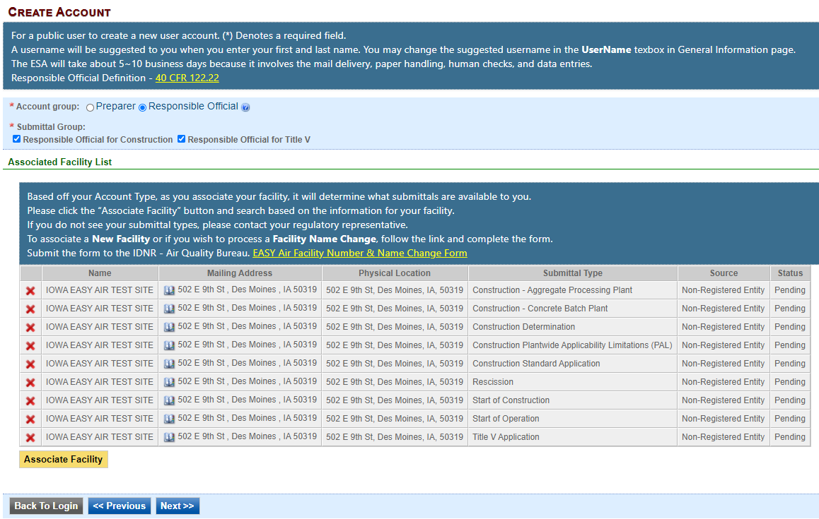
Figure 10 - Select Facility from Facility List

Click the blue “Next>>” button to continue the registration process in Section 2.4.

Select and answer Security Questions
The RO must assign answers to five security questions (Figure 11). These are required as part of the Certification process to submit a permit application through Iowa EASY Air. The questions and answers may be changed in the user's profile page within EASY Air back in Figure 3.
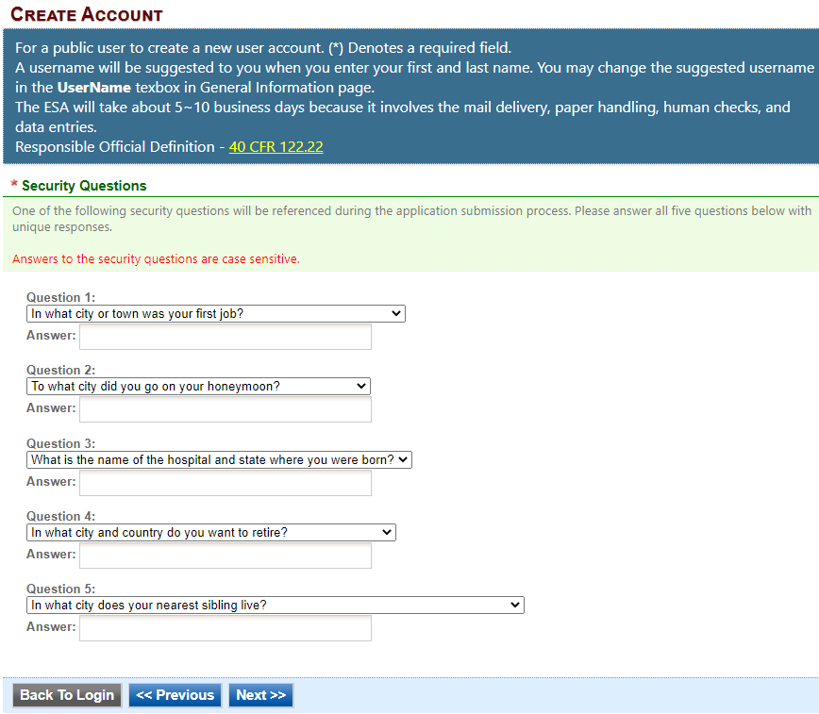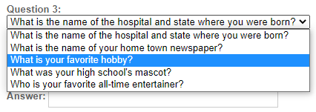
Figure 11 - Security Questions

There are 5 questions in the 5 question groups (see insert, Figure 11). Choose questions and answers that are easy for you to remember but difficult for others to guess. Click on the blue “Next>>” button when complete.

Pass Picture Verification
Enter the characters you see in Figure 12 (case sensitive). The characters are drawn so that it is possible for a person to recognize them, but very difficult for a program to. This helps us prevent automated programs from creating large numbers of accounts and sending spam. Then move down to the Identity Proofing section at the bottom of the page.
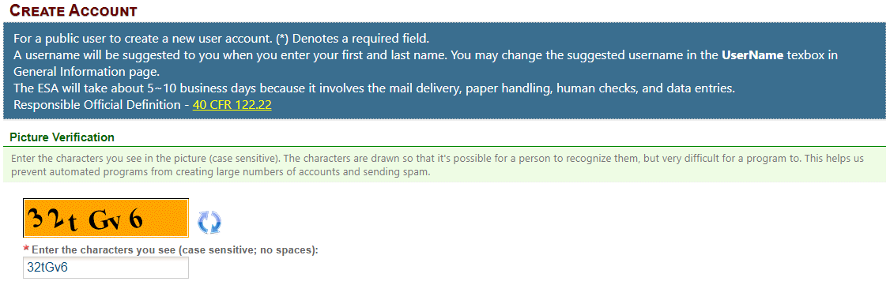
Figure 12 - Picture Verification

Select Identify Proofing Option
There are two types of user Identity Proofing in Iowa EASY Air shown in Figure 13. The e-Verify option uses a 3rd party identity verification company that is also used with submitting electronic records directly to the U.S. Environmental Protection Agency (EPA). The other method is by a paper Signature Agreement
(ESA) Form, validated by the Iowa DNR Air Quality Bureau. Both options are explained below.
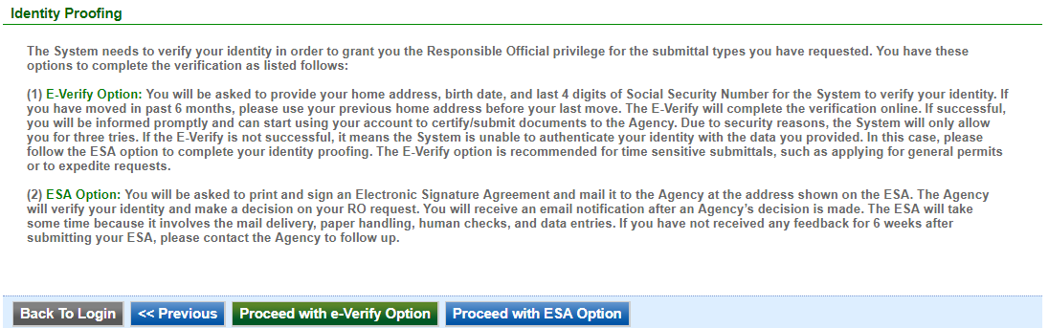
Figure 13 - User Verification Options

e-Verify Option
Click on the green “Proceed with e-Verify Option” button in Figure 13 to launch the connection to LexisNexis. Follow the instructions on screen to enter the validation information shown in Figure 14. Select the “Continue Registration Process” button when all information is completed.
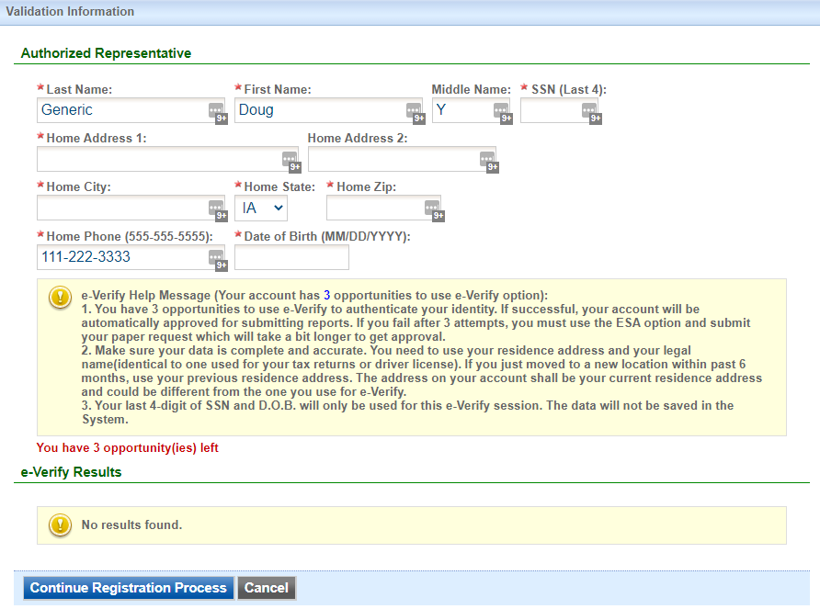
Figure 14 - e-Verify Option - Enter User Information

If the user passes all of the validation checks in the e-Verification process, click the blue “Save Profile Info” button to complete the verification. See Figure 15 for successful e-Verification in the User Account information.
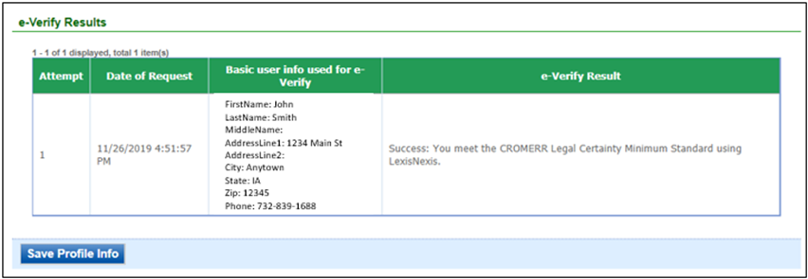
Figure 15 - e-Verify Successful
The e-Verify process makes all of your facilities and application (submittal) types active (Figure 16).
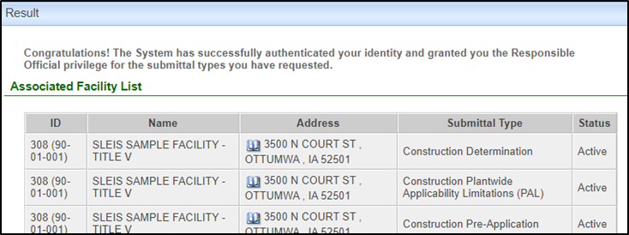
Figure 16 - e-Verify Completed
In the event that the e-Verify option is unsuccessful (Figure 17) the user will be prompted to complete their account creation by using the Electronic Subscriber Agreement option shown in Figure 13.
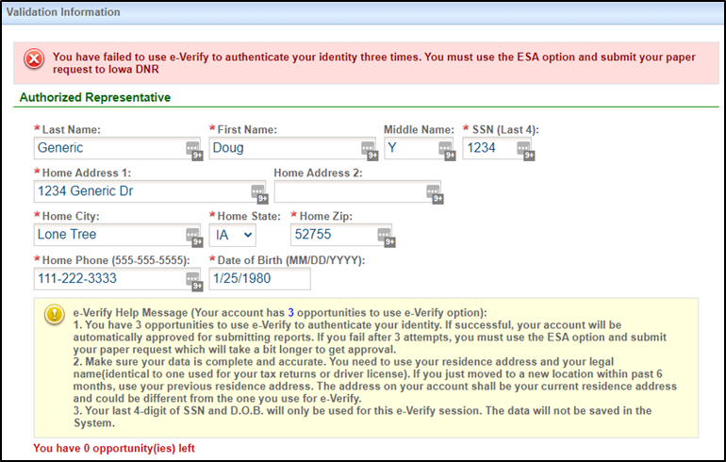
Figure 17 - e-Verify Unsuccessful

Electronic Signature Agreement (ESA) Option
Click on the blue “Proceed with ESA Option” button in Figure 13. This completes the Create Account process and presents Figure 18 to the user. The RO user can click the “Print the Subscriber Agreement” button to print to a printer or save as a PDF for Signature and mailing the ESA to the Air Quality Bureau.
Then click the “Back to Login” button to sign into Iowa EASY Air.
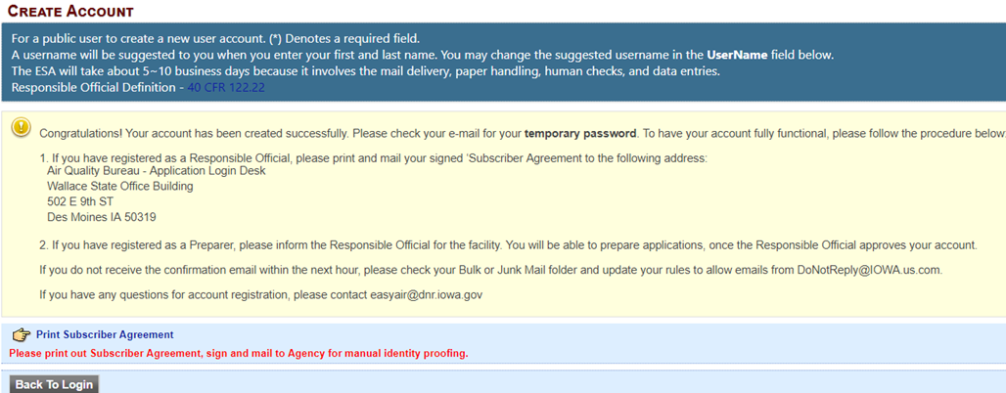
Figure 18 - Electronic Signature Agreement (ESA) Option

Receive email confirmation from Iowa EASY Air
Soon after you have successfully registered, you will receive an e-mail (Figure 19) from Iowa DNR that includes your Iowa EASY Air temporary password. This user ID and password are used one time to log into the Iowa EASY Air system for the first time.
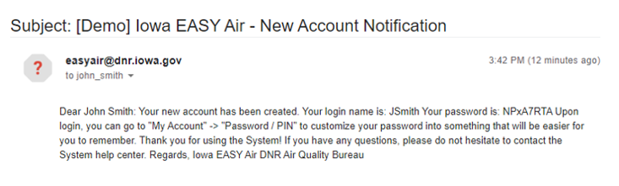
Figure 19 - Account Confirmation Email

Access Your Account Information
To view or make changes to your account information, log into Iowa EASY AIR (see Figure 1). Then click on the “My Account” tab (Figure 20). This page should be used to keep your Iowa EASY AIR account information up-to-date and change your password and manage your security questions. Users registered as a RO can use this section to request resetting their PIN. Figure 21 displays the information when the RO has successfully completed the e-Verify process.
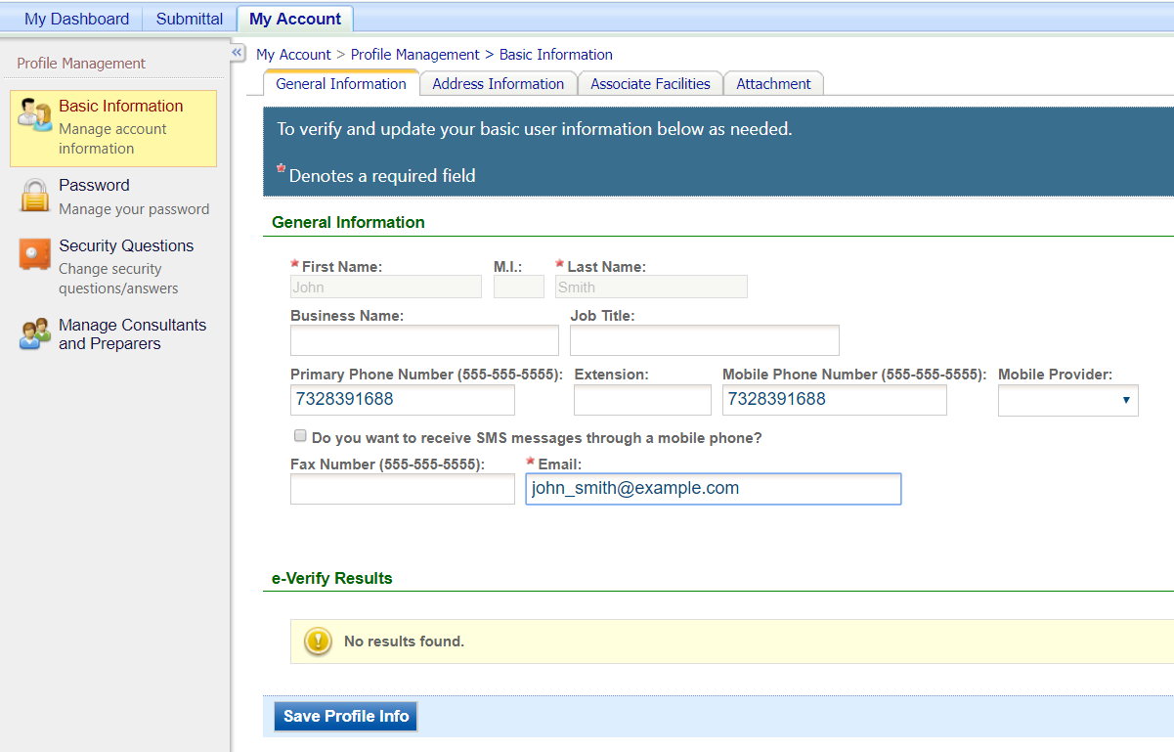
Figure 20 - Access “My Account”
If you successfully e-Verified your account, the bottom section of the Basic Information screen will show the success information (Figure 21). If you used the ESA method, the section will indicate "No results found."
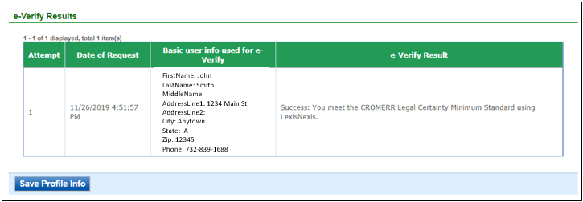
Figure 21 - Successful e-Verify Results

Request a New Facility Number or Process a Facility Change
When adding facilities to an applicant's user account (see section 2.3), either during new account creation (Section 2) or managing an existing account (Section 3), there are times when the search function does not return any facility records. One of the possibilities for this is that the facility does not exist in the database.

This may be due to a couple of reasons:
- The application is for a facility that is new or construction is planned in the future. It may be that the facility exists but has never had any permitting done and therefore also does not exist in the database.
- The facility has undergone an ownership change and the new name has not been entered in the database.

In both of these cases, the applicant will either need to request a facility number for the “new” facility, or request a facility name change.

When this occurs, the applicant should download the Iowa EASY Air Facility Number & Name Change Form (DNR Form 542-1056, from the Air Quality Bureau's eAirServices webpage or from within the Iowa EASY Air application.

If you have questions, please contact the Iowa EASY Air Help Desk
by sending an email to easyair@dnr.iowa.gov.
Or, call (515) 725-9569 or (515) 204-3749

